How to download apk on android FIRST TIME

Naomi , it’s the same one from jad and khateeb

1. **Allow unknown source**
2. You have to enable the installation from unknown sources on your device. To make it possible, perform the following steps:
3. Make sure to enable development access via your android.

* 1. Go to Settings > Apps > Special app access > Install unknown apps.

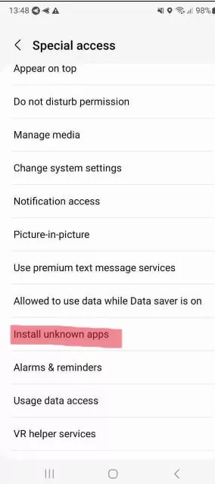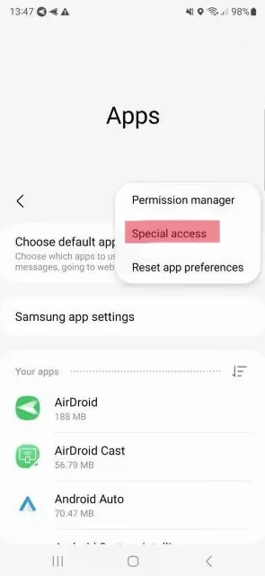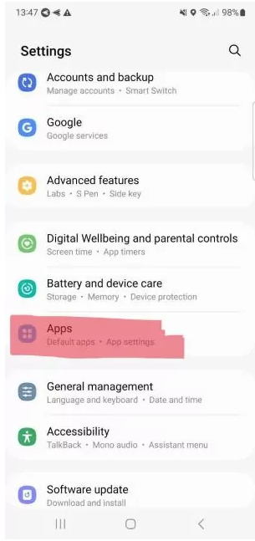

* 1**Find the APK file on your device.**  
  You can usually locate it in the **Downloads app**, or use a **file manager** to browse to the **Downloads** folder manually.
* 2. **Tap the APK file to begin the installation.**  
  If this is your first time installing an APK using that file manager, Downloads app, or browser, Android will show a warning and ask for permission to proceed.  
  Grant the permission. Depending on the app you're using, you might need to tap "Back" to return to the installer screen — or you may be taken there automatically.
* 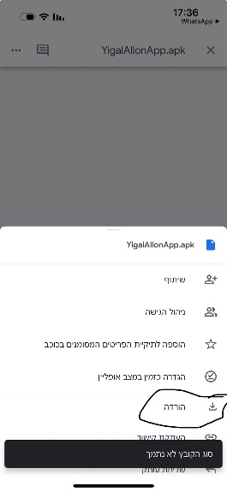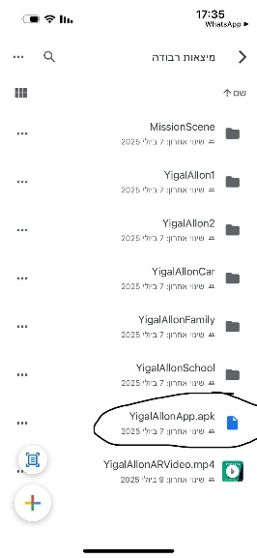3. Tap on Install, and the application will be installed successfully unless there